MSSQL India Genral Election-2024 Analysis
1) Total No of Seats
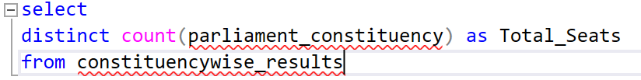
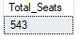
2) Total No of Seats available for elections in each state
(OR State wise total no of Seats)
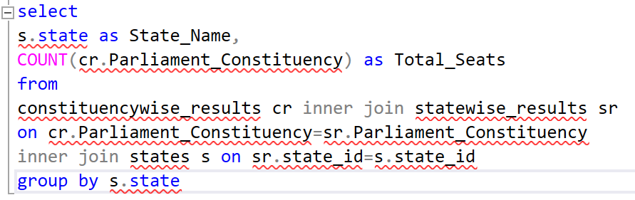
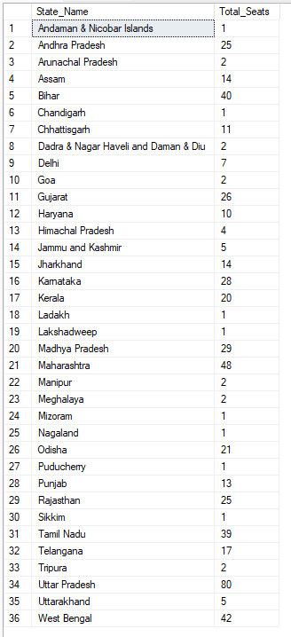
3) Total Seats won by NDA Alliance
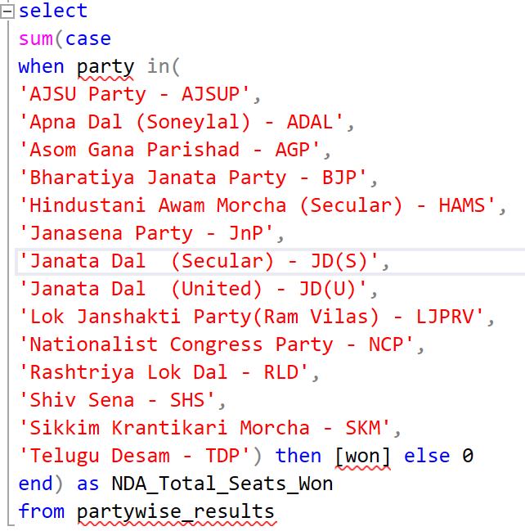
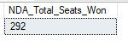
4) Seats won by NDA Alliance Parties
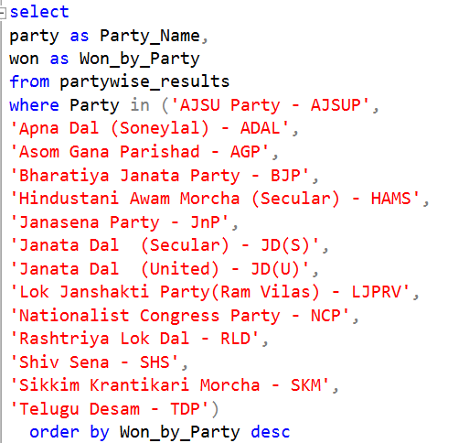
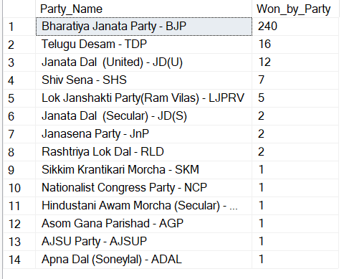
5) Total Seats won by I.N.D.I.A. Alliances Party
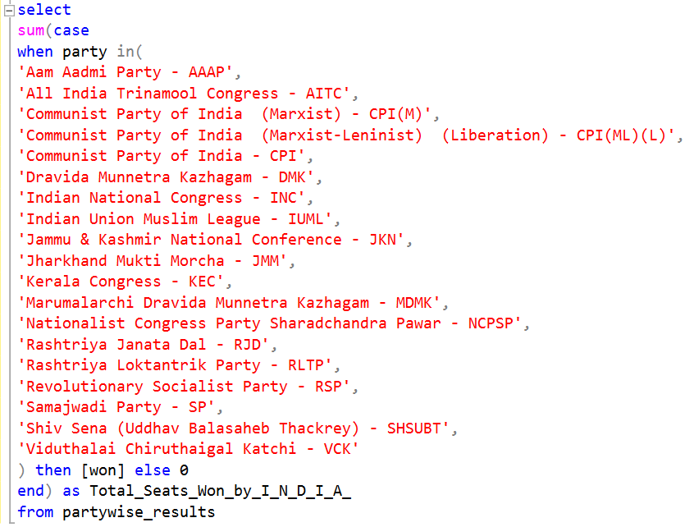
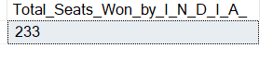
6) Seats won by I.N.D.I.A Alliance Parties
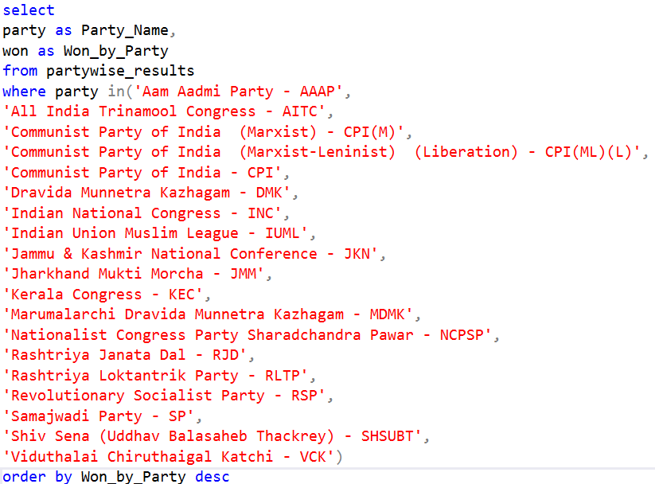
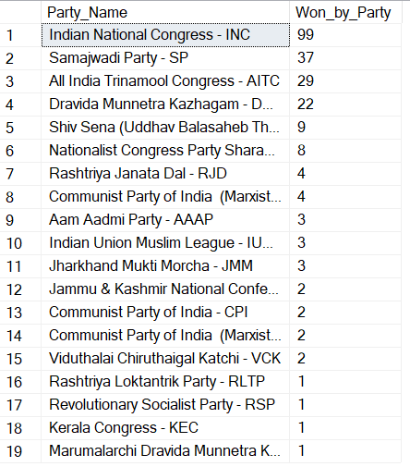
7) Add new table in Partywise_Results
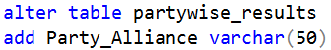
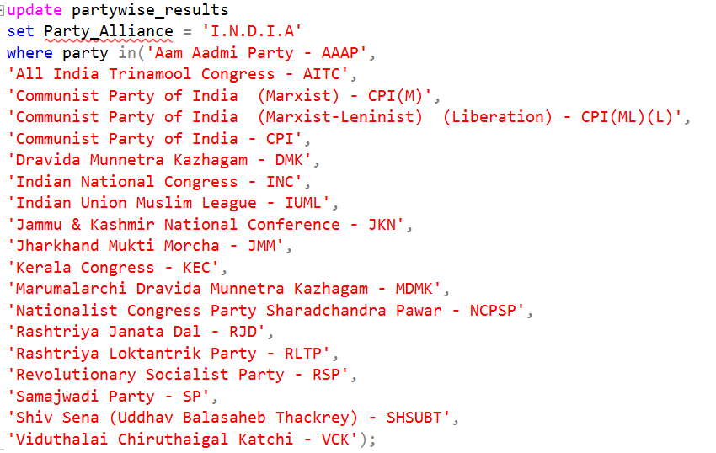
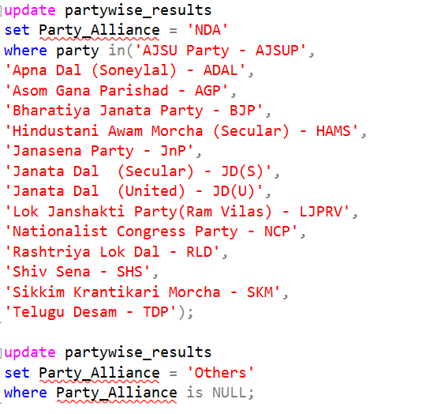
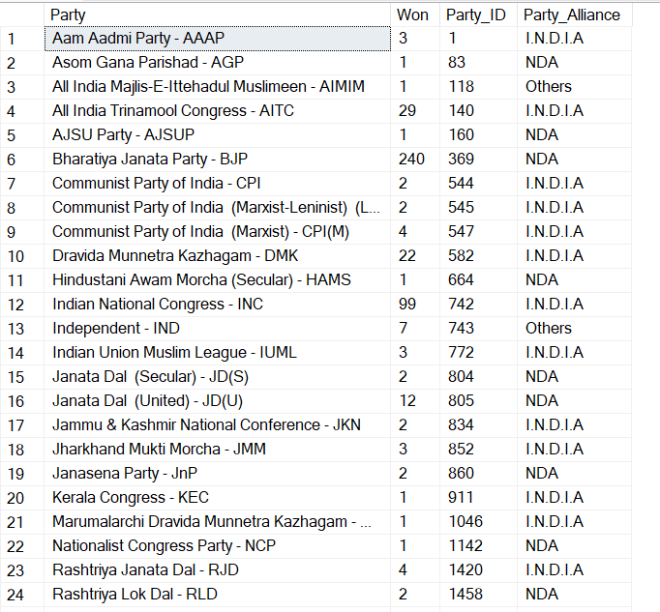
8) Which party alliance won the most seats across all the states?
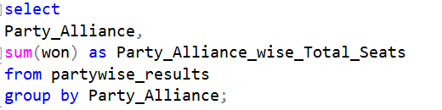
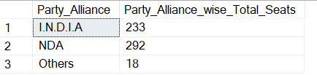
9) Winning Candidate, their party name, total votes and the margin of victory for a specific state and constituency
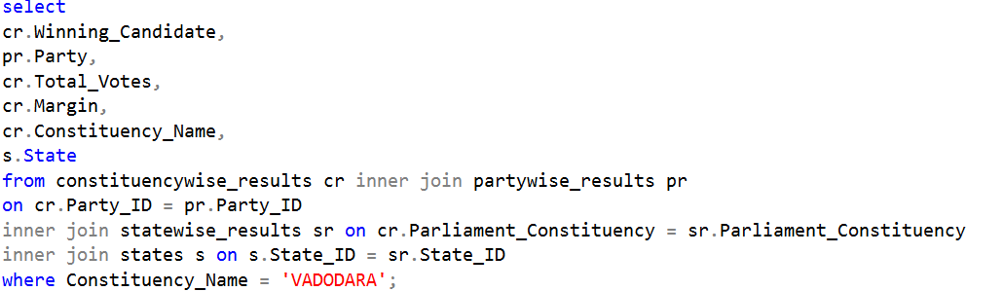
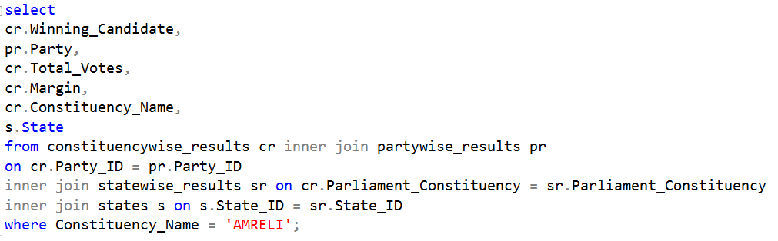
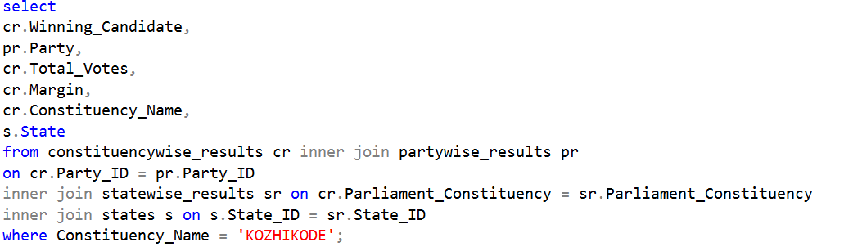
10) Distribution of EVM Votes verses Postal Votes for a candidate from a specific constituency
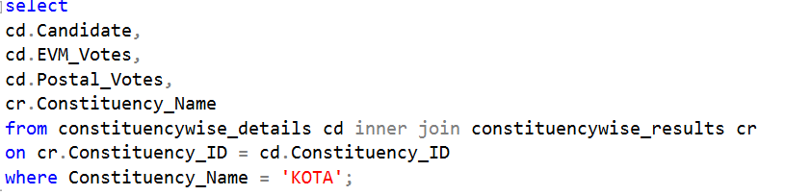
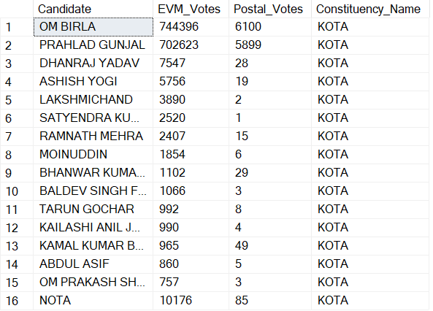
11) Which parties won the most seats in specific state and how many seats did each party win?
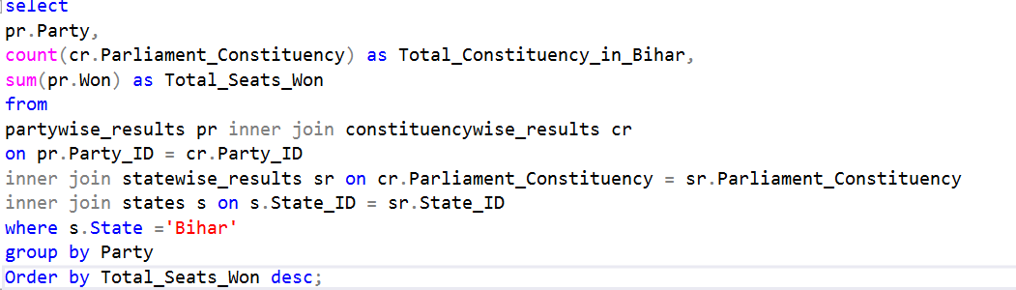
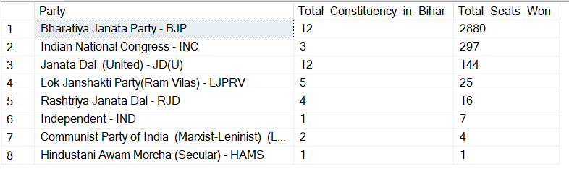
12) What is the total no of Seats won by each party alliance in each state in India Election 2024?
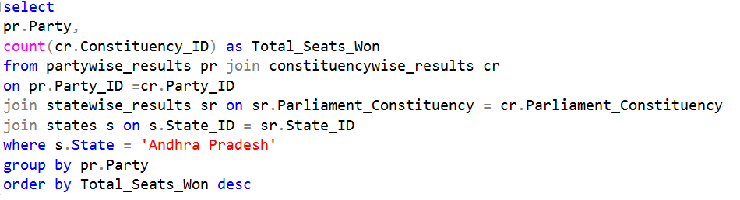
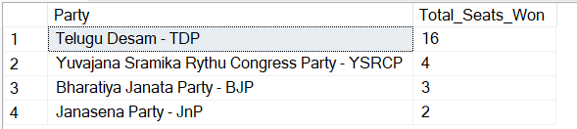
13) Which candidate received the highest number of EVM votes in each constituency (Top 10)?
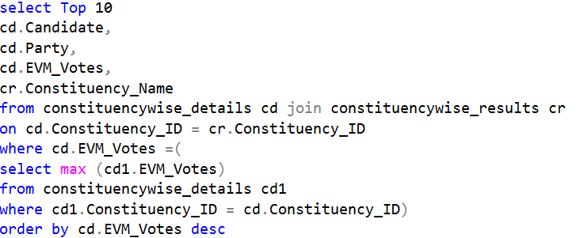
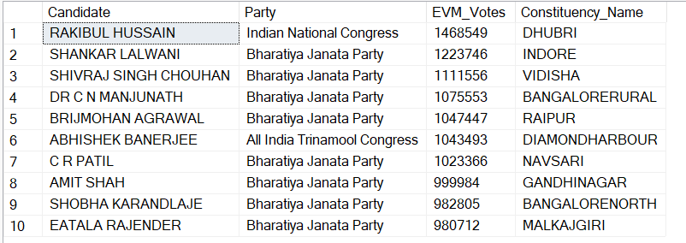
14) Which candidate won and which candidate is the runner up in each constituency of state for election 2024?
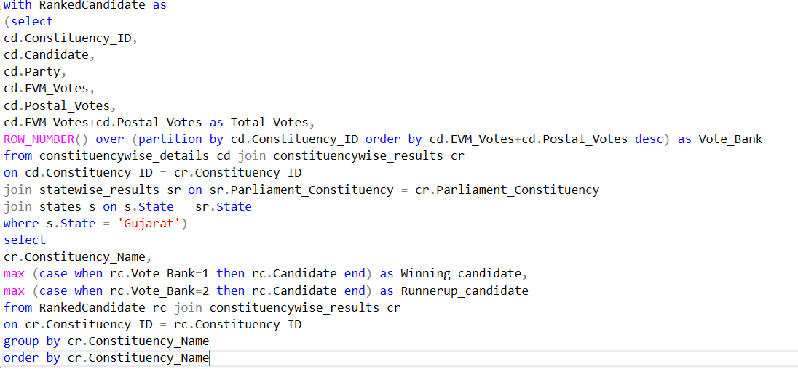
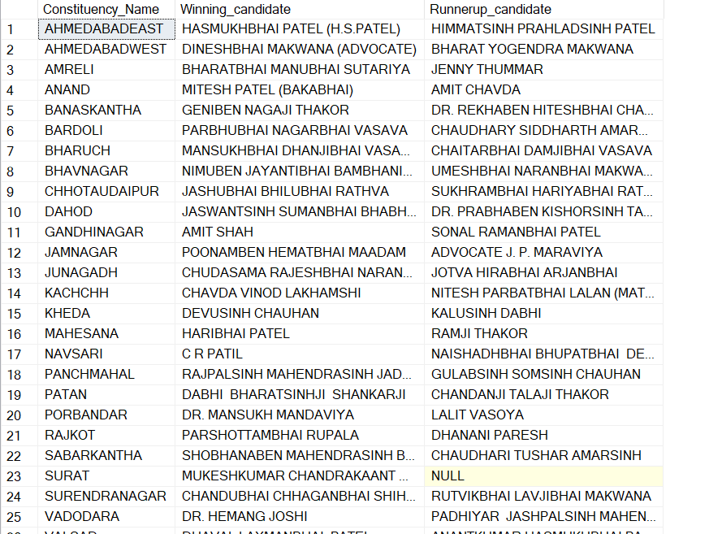
15) For the state of Gujarat, what are the Total no of Seats, Total no of Candidates, Total no of Parties, Total Votes (Including EVM and Postal Votes) and the breakdown of EVM and Postal Votes?
